|  |  |  |  |  |
| --- | --- | --- | --- | --- |
| Decorative | | | | |
|  |  |  | |  |
| SQL TASKS  A printout of a EER model  Parisa Azimivahdat | | |
| JUSTIT | | parisaazimivahdat.bootcamp@justit.co.uk |

|  |
| --- |
| Selecting all records from the database ‘sql_store’ and table ‘customers’.    Selecting all records from the table ‘customers’, using the database ‘sql_store’.    Selecting customer with customer id 1.    Selecting customer id number 1, ordered first name in alphabetical order. |
| Select last name before first name with points and points plus 10.    Select last name, first name, points and points multiplies with 10 and plus 100 and rename the column as ‘discount_factor’. |
| Select last name, first name, points, points plus 10 and multiplied with 100 as ‘discount_factor’.    Select products’ names, unit price and a new unit price from the customer table.    Select all customers born after 01-01-1990.    The EER Diagram |

The primary key for the order_items_notes tale must be set manually using the note_id column.

|  |  |
| --- | --- |
|  |  |

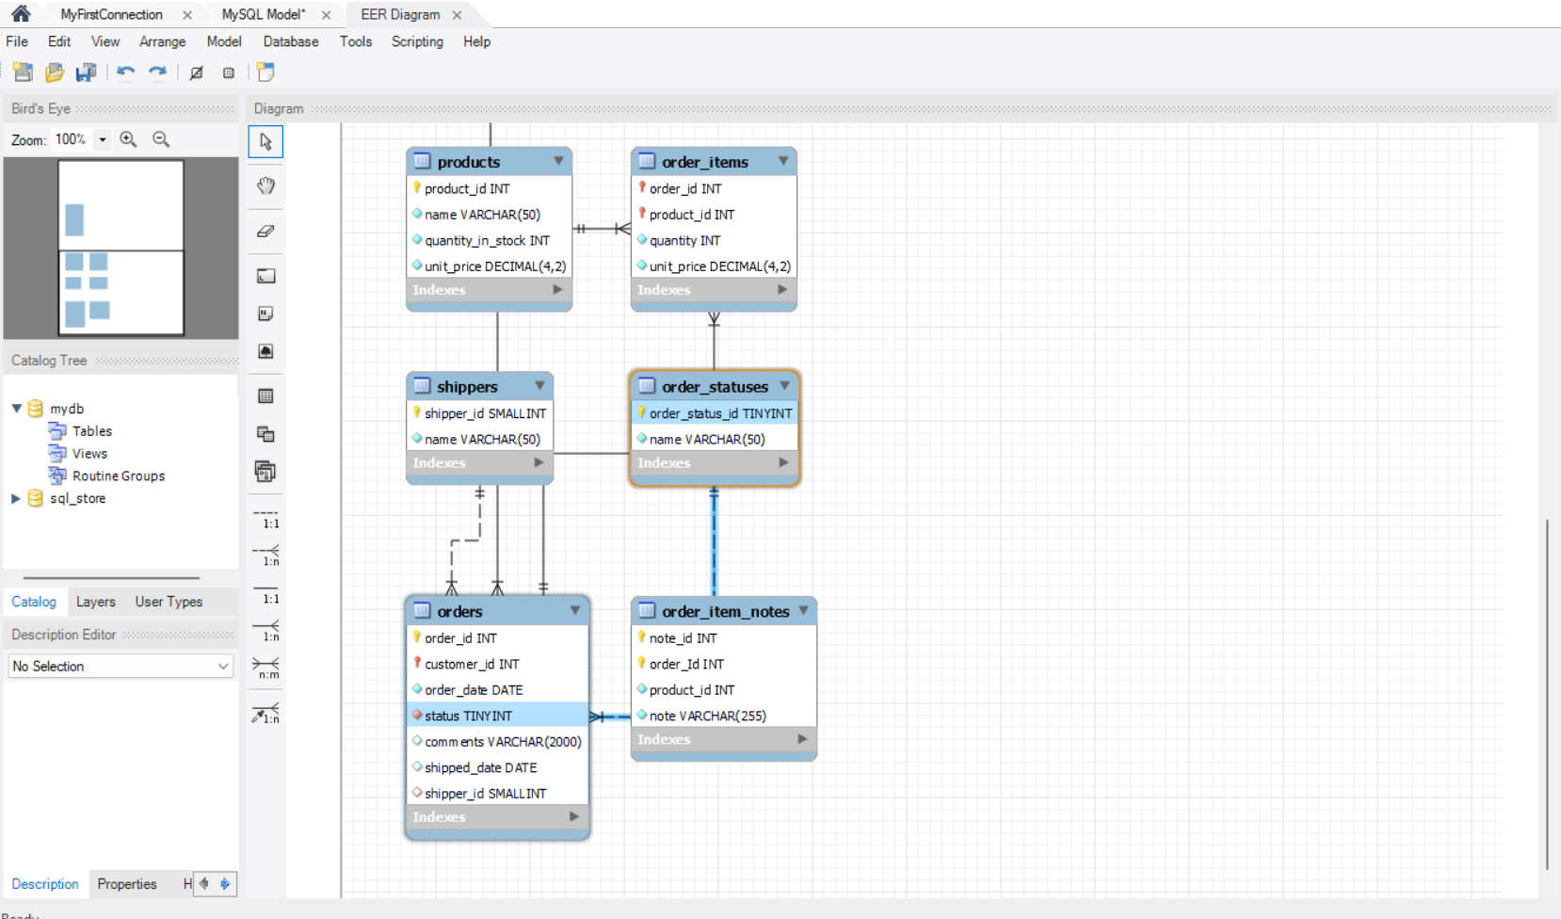

All tables now have primary keys.